17-Jan-2019

* Remove \\GST\\PDB\\ in the line:

aln.append_model(mdl, align_codes=pdb+chain, atom_files=

and replace that with \\Data\\"+mydir+"\\PDB\\"+pdb+'.pdb') .

* Try the wget command, as the downloaded file format(.pdb) is different from the file format in the tutorial file(>Basic example>1bdm.pdb).

# url = "https://files.rcsb.org/download/"+pdb+".pdb" # Actual Code, The following one will not be valid code.

url = "https://files.rcsb.org/download/1bdm.pdb" # Just for Try

file1 = wget.download(url, os.getcwd()+"\\Data\\"+mydir+"\\PDB\\")

* Add Log generation code

os.makedirs(os.path.join(os.getcwd()+"\\Data\\",mydir+"\\PAP"))

os.makedirs(os.path.join(os.getcwd()+"\\Data\\",mydir+"\\Logs"))

# Gerenating Logs

sys.stdout = open(os.getcwd()+"\\Data\\"+mydir+"\\Logs\\ModellerGUI Log.txt", "w") # Printing Logs

22-Jan-2019

* Check this: <https://likegeeks.com/python-gui-examples-tkinter-tutorial/>

28-Jan-2019

* Working on the PDB file error (found 11 colons instead of 10 colons), and wrong PDB file format (the downloaded one) from the PDB file which is used in Tutorial.
  + Actually, this problem is in Model-Single.py, in the a.make().
* There are many problems in this Modeller GUI program
  + GUI not made correctly, needs upgradation.
  + Program hangs while printing logs file. Possibly Multi-Threading is necessary.
  + Ali file chooser button is not working correctly.
  + Model-Single.py is giving error.
  + GUI must be reporting while having any error.
* I am learning Threading and Classes in python.
* This project needs to restart again fresh.

28-Jan-2019

* Learning Python Multithreading to solve hanging issue of the app.

17-Feb-2019

* Creating 2 separate files
  + [1] Controller: Which holds the Modeller python scripts (whole logical codes).
  + [2] GUI: Which holds the GUI part.

18-02-2019

* I mailed the modeller team
  + 
  + 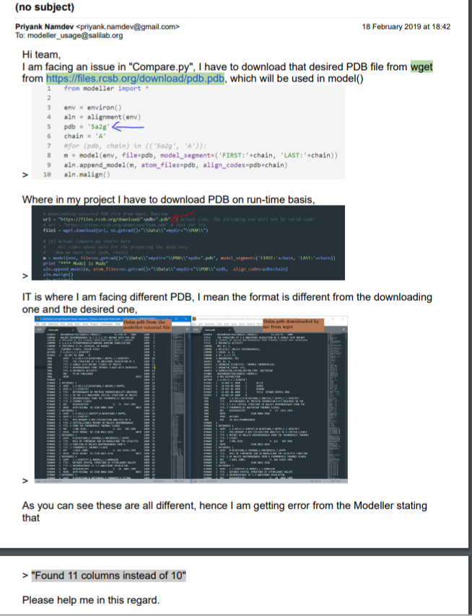
  + Working on GUI as well as the logic code with multithreading.
  + Maybe I must follow this link: <https://salilab.org/archives/modeller_usage/2008/msg00110.html>

21-02-2019

* Mailed to Modeller team regarding our issue, they asked the error codes and the alignment file. Sent them.
* Working on the Threading

27-02-2019

* I think that Controller.py and GUI.py codes should be under one file as the threading is not working properly for different files simultaneously.

28-03-2019

* I got one possible error point in B0FGV7-5a2gA.ali file, as Ben (from Modeller team) suggests, the file having full path of PDB file, instead of just having name of it. Working of it.
* Now I am working on a separate code which eliminates the extra code.
  + We can remove the string and write that new string on that file
  + Or we take whole file as a string, work on it, and then make a new file with correct output and delete the old file.

29-03-2019

* Finally, I sorted out the error, now code is working.
* Now, there is an error in Model-Single.py

09-04-2019

* One probable solution of alignment.make() in Align2D is that the PDB (in our case 5a2g.pdb) is in the \PDB\ folder whereas the program is working in the parent folder, Which proves the error to be true , which is “can’t find the PDB file name”.
  + For this I wrote code to copy runtime the PDB file in the parent folder (\OnWorking\) and one in the \Output ALI\ for testing purpose.

10-04-2019

* So, the above problem is sorted now.
* Code is working correctly.
* There are minor updated must be done:
  + Variables and files closing(cleaning) after the completion of code.
  + Downloaded PDB (as in our case 5a2g.pdb) are runtime copied on parent directory for further processing, which must be deleted as its replica is stored in Data>PDB folder.
  + GUI is to be clean and refresh by adding more features.
  + Logs file is not printing.
  + CUI part should be shown to user side by side to GUI part.
  + GUI part will be updated to Python 3 from Python 2.

24-04-2019

* Refined Open ALI/Fasta files button.
* Refined directory folder making code.

25-04-2019

* Refining Open ALI/Fasta files button.
* Evaluate-model is working as the files are now moving to there expected location.
* Open/ALI files button should be removed, and all the files directly are in the folder should be copied on expected folder.
* There should be output folder instead of Data folder in the parent directory.
* Alignments folder is named Inputs now.